Project Planning Phase

**Project Planning Template (Product Backlog, Sprint Planning, Stories, Story points)**

|  |  |
| --- | --- |
| Date | 22 October 2022 |
| Team ID | PNT2022TMID40107 |
| Project Name | Crude Oil Price Prediction |
| Maximum Marks | 8 Marks |

# Product Backlog, Sprint Schedule, and Estimation (4 Marks)

Use the below template to create product backlog and sprint schedule

|  |  |  |  |  |  |  |
| --- | --- | --- | --- | --- | --- | --- |
| **Sprint** | **Functional Requirement (Epic)** | **User Story Number** | **User Story / Task** | **Story Points** | **Priority** | **Team Members** |
| Sprint-1 | Data Collection | USN-1 | Download Crude Oil Price Dataset | 2 | Medium | Oviya CM |
| Sprint-1 | Data Preprocessing | USN-2 | Importing The Dataset into Workspace | 1 | Low | Jabez Jacob J |
| Sprint-1 |  | USN-3 | Handling Missing Data | 3 | Medium | Vijayarajan R |
| Sprint-1 |  | USN-4 | Feature Scaling | 3 | Low | Shrishakthi K |
| Sprint-1 |  | USN-5 | Data Visualization | 3 | Medium | Vijayarajan R |
| Sprint-1 |  | USN-6 | Splitting Data into Train and Test | 4 | High | Oviya CM |
| Sprint-1 |  | USN-7 | Creating A Dataset with Sliding Windows | 4 | High | Vijayarajan R |
| Sprint-2 | Model Building | USN-8 | Importing The Model Building Libraries | 1 | Medium | Shrishakthi K |
| Sprint-2 |  | USN-9 | Initializing The Model | 1 | Medium | Jabez Jacob J |
| Sprint-2 |  | USN-10 | Adding LSTM Layers | 2 | High | Vijayarajan R |
| Sprint-2 |  | USN-11 | Adding Output Layers | 3 | Medium | Oviya CM |
| Sprint-2 |  | USN-12 | Configure The Learning Process | 4 | High | Shrishakthi K |

|  |  |  |  |  |  |  |
| --- | --- | --- | --- | --- | --- | --- |
| **Sprint** | **Functional Requirement (Epic)** | **User Story Number** | **User Story / Task** | **Story Points** | **Priority** | **Team Members** |
| Sprint-2 |  | USN-13 | Train The Model | 2 | Medium | Vijayarajan R |
| Sprint-2 |  | USN-14 | Model Evaluation | 1 | Medium | Oviay CM |
| Sprint-2 |  | USN-15 | Save The Model | 2 | Medium | Jabez Jacob J |
| Sprint-2 |  | USN-16 | Test The Model | 3 | High | Shrishakthi K |
| Sprint-3 | Application Building | USN-17 | Create An HTML File | 4 | Medium | Jabez Jacob J |
| Sprint-3 |  | USN-18 | Build Python Code | 4 | High | Vijayarajan R |
| Sprint-3 |  | USN-19 | Run The App in Local Browser | 4 | Medium | Oviya CM |
| Sprint-3 |  | USN-20 | Showcasing Prediction On UI | 4 | High | Shrishakthi K |
| Sprint-4 | Train The Model On IBM | USN-21 | Register For IBM Cloud | 4 | Medium | Vijayarajan R |
| Sprint-4 |  | USN-22 | Train The ML Model On IBM | 8 | High | Vijayarajan R |
| Sprint-4 |  | USN-23 | Integrate Flask with Scoring End Point | 8 | High | Vijayarajan R |

# Project Tracker, Velocity & Burndown Chart: (4 Marks)

|  |  |  |  |  |  |  |
| --- | --- | --- | --- | --- | --- | --- |
| **Sprint** | **Total Story Points** | **Duration** | **Sprint Start Date** | **Sprint End Date (Planned)** | **Story Points Completed (as on Planned End Date)** | **Sprint Release Date (Actual)** |
| Sprint-1 | 20 | 6 Days | 24 Oct 2022 | 29 Oct 2022 | 20 | 29 Oct 2022 |
| Sprint-2 | 20 | 6 Days | 31 Oct 2022 | 05 Nov 2022 | 20 | 03 Nov 2022 |
| Sprint-3 | 20 | 6 Days | 07 Nov 2022 | 12 Nov 2022 | 20 | 10 Nov 2022 |
| Sprint-4 | 20 | 6 Days | 14 Nov 2022 | 19 Nov 2022 | 20 | 17 Nov 2022 |

**Velocity:**

Imagine we have a 10-day sprint duration, and the velocity of the team is 20 (points per sprint). Let’s calculate the team’s average velocity (AV) per iteration unit (story points per day)

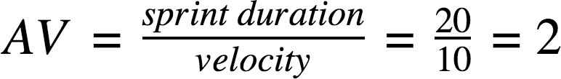

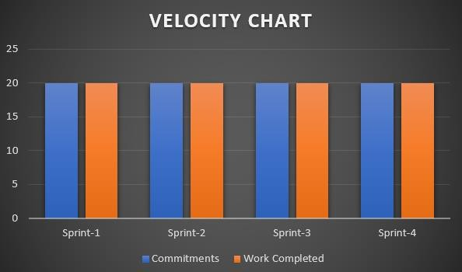

# Burndown Chart:

A burn down chart is a graphical representation of work left to do versus time. It is often used in agile [software development](https://www.visual-paradigm.com/scrum/what-is-agile-software-development/) methodologies such as [Scrum](https://www.visual-paradigm.com/scrum/scrum-in-3-minutes/). However, burn down charts can be applied to any project containing measurable progress over time.

